Worksheet 8

Student Name:Aryan Tomar UID:25MCI10167
Branch:MCA (AI&ML) Section/Group:1/A
Semester:2nd Date of Performance:02/04/2026
Subject Name:- DBMS LAB Subject Code: 25CAP-652

1. Aim of the Session

To apply the concept of Stored Procedures in database operations in order to perform tasks like insertion,updating, deletion, and retrieval of data efficiently, securely, and in a reusable manner within the database system.

2. Software Requirements
- PostgreSQL (Database Server)
- pgAdmin
- Windows Operating System

3. Objective of the Session

To understand and implement stored procedures for performing database operations like insertion, updating, deletion, and retrieval in an efficient and reusable manner.

4. Practical / Experiment Steps

Prerequisite Understanding

• Students should understand basic SQL operations such as SELECT, INSERT, UPDATE, and DELETE.

• Students should be familiar with table creation and data types in PostgreSQL.

• Students should understand the concept of functions and procedures in programming.

• Students should have basic knowledge of PL/pgSQL blocks (BEGIN, END, DECLARE).

• Students should understand parameters (IN, OUT, INOUT) used in stored procedures.

• Students should be aware of basic conditional statements like IF–ELSE and exception handling.

5. Procedure of the Practical

(i) Start the system and log in to the computer.

(ii) Open PostgreSQL software.

iii) Create and select the database.

Create database Practical8;

(iv) Create table using DDL command.

CREATE TABLE Employees2 (

emp_id INT PRIMARY KEY,

emp_name VARCHAR(50),

manager_id INT,

department VARCHAR(50),

salary INT

);

(v) Insert records into the table.

INSERT INTO Employees2 VALUES

(1, 'Amit', NULL, 'Management', 120000),

(2, 'Ravi', 1, 'Engineering', 80000),

(3, 'Neha', 1, 'Engineering', 82000),

(4, 'Karan', 2, 'Engineering', 60000),

(5, 'Simran', 2, 'Engineering', 62000),

(6, 'Pooja', 3, 'Engineering', 61000),

(7, 'Rahul', 3, 'Engineering', 64000),

(8, 'Arjun', 1, 'HR', 70000);

(vi) Display all records.

select * from employee;

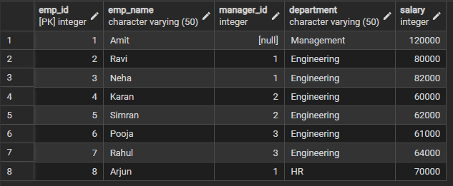

Step 1: Creating a procedure
create or replace procedure update_salary_procc(IN p_emp_id int,inout p_salary numeric(20,3),OUT status varchar(20))
AS
$$
declare
curr_sal numeric(20,3);
begin
select salary+p_salary into curr_sal from Employees2 where emp_id=p_emp_id;
if not found then
raise exception 'employee not found';
end if;

update Employees2
set salary=curr_sal
where emp_id=p_emp_id;
p_salary:=curr_sal;
status:='success';
exception
when others then
if sqlerrm like '%employee not found%' then
status:='employee not found';
end if;
end;
$$ language plpgsql;

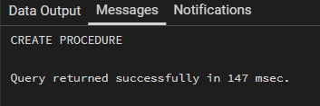

Step 2: Execute Procedure (Invalid Employee Case)
do
$$
declare
emp_id int :=99;
status varchar(20);
salary numeric(20,3):=500;
begin
call update_salary_procc(emp_id,salary,status);
raise notice 'your status is %',status;
end ;
$$

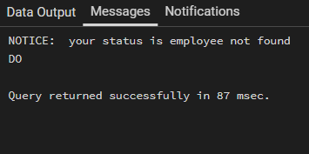

Step 3: Execute Procedure (Valid Employee Case)
do
$$
declare
emp_id int := 1;
status varchar(20);
salary numeric(20,3) := 500;
begin
call update_salary_procc(emp_id, salary, status);
raise notice 'your status is %', status;
end;
$$;
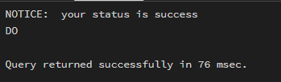

Step4 :Verify Updated Data
select * from Employees2;

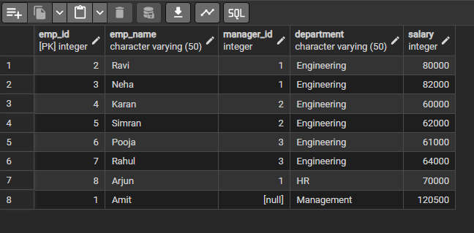
6. I/O Analysis (Input / Output)
Input:
• Employee records inserted into the Employees2 table
• Stored procedure definition with IN, OUT, and INOUT parameters
• Employee ID and salary increment value passed as input
• PL/pgSQL DO blocks used to call the procedure
• Conditional logic and exception handling inside the procedure
Output:
• Salary updated successfully for valid employee IDs
• Error message handled when employee is not found
• Status message returned as ‘success’ or ‘employee not found’
• Updated salary reflected in the Employees2 table
• Proper execution of stored procedure with parameter passing
• Reusable business logic implemented inside the database
7. Learning Outcomes
• Understood the concept and use of stored procedures in PostgreSQL
• Learned how to use IN, OUT, and INOUT parameters effectively
• Gained experience in writing reusable and efficient database logic
• Understood exception handling using PL/pgSQL
• Learned how to perform conditional updates within procedures
• Developed skills to implement business logic at the database level
• Improved understanding of procedural SQL for real-world applications

